**Longines welcomes Henry Cavill —   
timeless elegance in a modern spirit**

**Longines is proud to welcome Henry Cavill as its newest Ambassador of Elegance. The acclaimed actor brings a unique blend of refinement and authenticity that perfectly embodies the brand’s ethos that elegance is an attitude.**

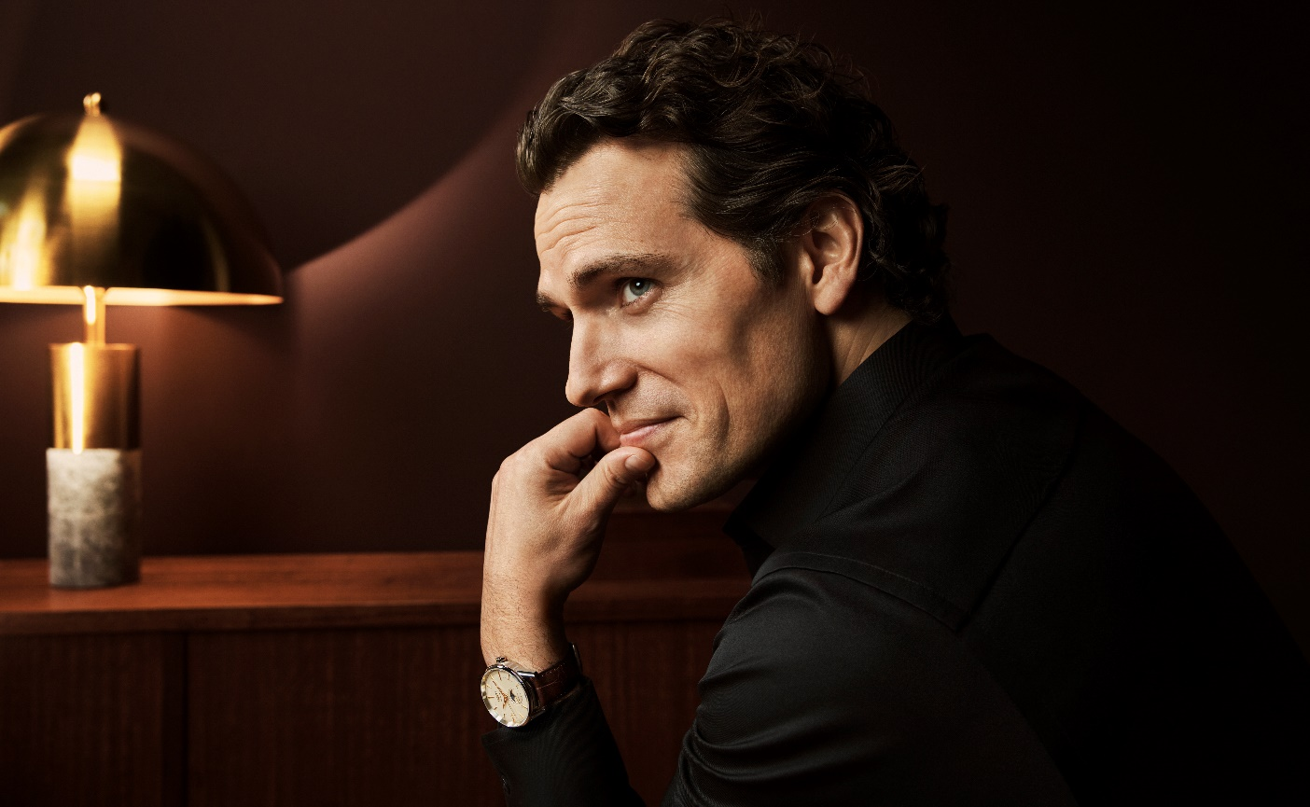

This partnership represents Longines’ legacy of collaborating with individuals who exemplify true elegance in both their professional excellence and personal conduct. As an Ambassador of Elegance, Cavill will join Longines in celebrating the timeless sophistication that has characterized the brand since its founding in 1832.

Matthias Breschan, Longines’ CEO, warmly welcomed this new partnership: “In Henry, we recognize a real affinity with our brand’s values. His sophistication, genuine warmth and multifaceted personality reflect what elegance means today. Whether commanding the screen in epic productions or sharing his passions for aviation and equestrianism, he maintains an authenticity and grace that makes him a clear embodiment of the Longines spirit.”

“What draws me to Longines is their understated elegance,” says Cavill. “True quality doesn’t need to announce itself. It’s evident in every detail and in every action. This is a philosophy, backed by generations of precision craftsmanship and artistry, that resonates deeply with my own values.”

Henry Cavill has established himself as one of the most versatile actors of his generation. From his globally-beloved portrayal of Superman in the DC universe, to Mission: Impossible - Fallout, to Guy Ritchie's The Man from UNCLE and more, Cavill has demonstrated remarkable range as a performer. He continues to evolve as an artist by pursuing projects that speak to his genuine interests, including executive producing and starring in an adaptation of the Warhammer 40,000 universe for Amazon Prime Video. He will star next in the live-action Voltron film for Amazon MGM Studios.

Beyond the screen, Cavill is known for defying expectations. An accomplished actor who is also passionate about gaming, he brings the same dedication and finesse to every pursuit. This extends to his production company, Promethean Productions, which focuses on developing original storytelling that carries both meaning and impact.

As Longines embarks on this new chapter, Cavill plans to take time out from his many upcoming projects to visit the brand's historic headquarters in Saint-Imier, Switzerland, where he will have the pleasure of seeing firsthand the dedication to craftsmanship that has defined the Swiss watchmaker for nearly two centuries.

***About Longines***

*Established in Saint-Imier, Switzerland in 1832, Longines’ expertise is steeped in tradition, elegance and performance. With its lengthy experience as an official timekeeper of world sports championships and partner of international sports federations, the Swiss watch brand has forged solid, enduring links with the world of sports over the years. Famous for the elegance of its timepieces, Longines is a member of the Swatch Group Ltd, the world’s leading manufacturer of timepieces. The brand Longines, with its winged hourglass emblem, is represented in over 150 countries.*